17、 Infrared remote control

**Follow the steps to splice the building blocks ：**

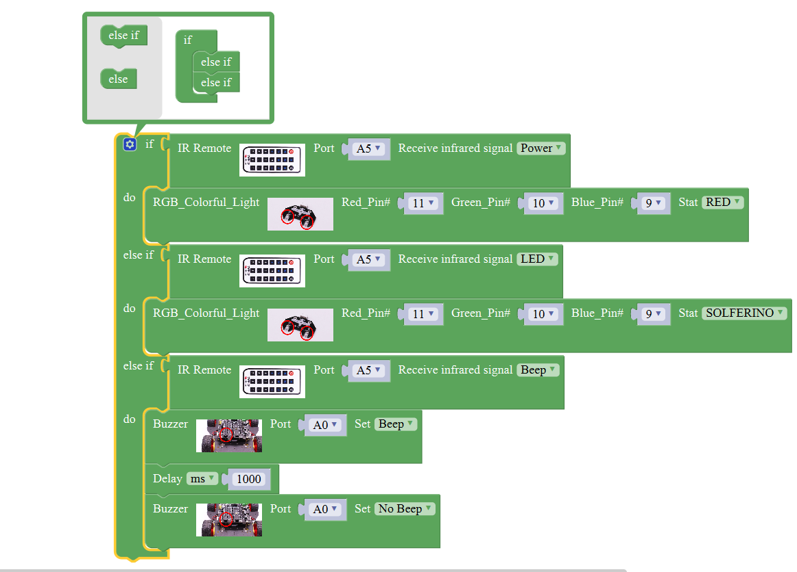

**1、Experimental building blocks :**

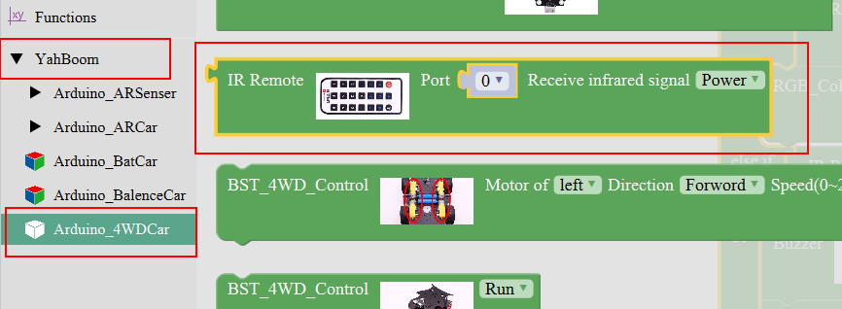

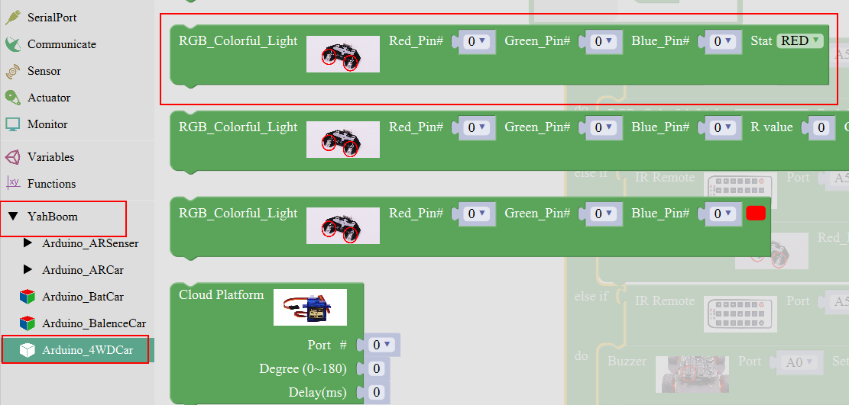

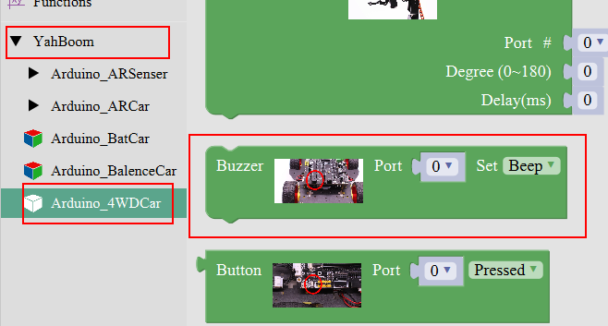

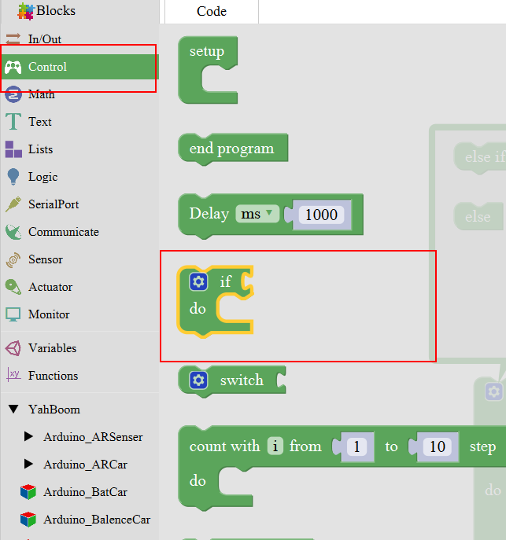

**2、Experimental verification：**

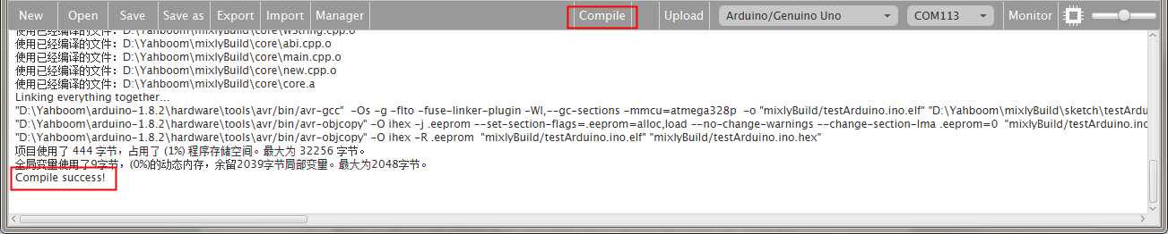

a、After splicing, select the compile button above the picture, wait for the completion of the compiler, the following box will prompt the compiler successfully, if prompt the compile failure is the problem of building block splicing.

b、After compiled , select **Arduino/Genuino Uno** follow the picture,

selects the serial number of the corresponding board.

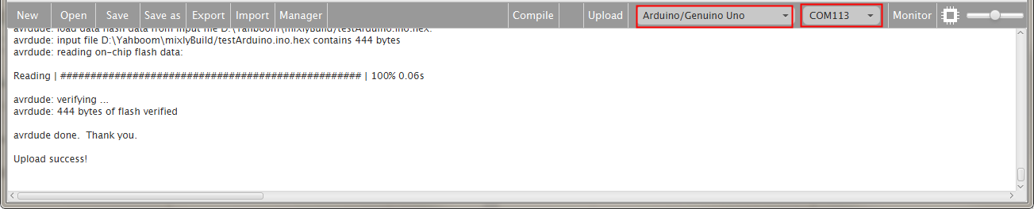

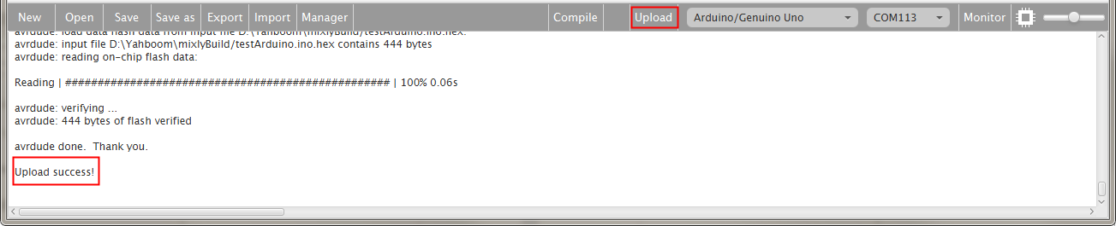

c、After configured,select the upload button above the picture, wait for the following box prompt the upload successfully.If the red power button is pressed, the red light will start; press the white light button, the car is bright red; press the horn key, and the car will whistle for one second.

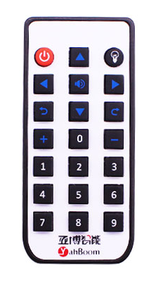

telecontroller